
THE MAHARAJA SAYAJIRAO UNIVERSITY OF BARODA
FACULTY OF SCIENCE
DEPARTMENT OF STATISTICS

ACADEMIC YEAR 2025-26

PROJECT REPORT
on

“Artificial Intelligence and Student Life : A Study of Its Influence on Learning, Behaviour and Social Life”

MSc Statistics (Team 8) Guided by: Prof. Murlidharan Kunnumal
Palak Kumawat
Krupa Valand
Jamil Mahida
Priyanshi Gandhi

Table of Contents

Abstract 3
Acknowledgement 4

1. Introduction 5

2. Objectives of the Study 6

3. Pilot Study 7

4. Sampling Design 8

5. Questionnaire Design 10

6. Reliability Analysis 11

7. Data Visualisation and Descriptive Analysis 12

8. Statistical Inference 24

9. Conclusion 50

10. References 53

Appendix A: Complete Questionnaire (Word for Word) 54

Abstract

This study investigates "Artificial Intelligence and Student Life: A Study of Its Influence on Learning, Behaviour, and Social Life". With the rapid integration of AI tools such as ChatGPT, Google Gemini, and Microsoft Copilot into the daily routines of school students, this research examines their influence on academic performance, cognitive development, emotional well-being, social behaviour, and overall quality of student life.

Primary data were collected from 340 students across 10 schools in Vadodara using a structured questionnaire, with sampling conducted through a Multistage design — Cluster Sampling (zone-based school selection) followed by Proportionate Stratified Sampling (student selection within schools). Reliability of measurement scales was confirmed using Cronbach's Alpha, with the overall questionnaire achieving α = 0.825, indicating good internal consistency.
The study employs one-sample t-tests, Wilcoxon Signed-Rank tests, Chi-Square Goodness-of-Fit tests, ANOVA, and Kruskal-Wallis tests to address six research objectives spanning positive impacts, cognitive development, platform usage patterns, negative effects, behavioural risks, and overall AI influence.

Acknowledgement

We, the members of Team 8 of the MSc Statistics Previous Year 2025-26 at The Maharaja Sayajirao University of Baroda, wish to express our sincere gratitude to all individuals and institutions whose support made this research project possible.

First and foremost, we extend our deepest appreciation to our project mentor, Prof. Murlidharan Kunnumal, Department of Statistics, Faculty of Science, The Maharaja Sayajirao University of Baroda. His expert guidance, continuous intellectual engagement, and constructive feedback at every stage of this project from conceptualisation and questionnaire design to statistical analysis and interpretation were invaluable. His insistence on methodological rigour and clarity of thought has profoundly shaped the quality of this work.

We are grateful to the Department of Statistics, MSU Baroda, for providing the academic environment and resources necessary to undertake this research.

1. Introduction

The rapid integration of artificial intelligence (AI) into higher education is reshaping how students engage with academic content and spend their free time, yet its impact on their well-being remains underexplored. Despite the growing use of AI in both academic tasks and personal activities, empirical studies on its effects on student well-being are notably scarce. This study addresses this gap by conducting a mini-review that seeks to synthesize the limited experimental and empirical evidence available on this critical issue. While the small number of studies reflects the early stages of research in this field, it is vital to establish a clear understanding of what is currently known. By doing so, this mini-review lays the groundwork for future empirical investigations, highlighting the importance of exploring how AI affects students’ mental health, social interactions, and overall well-being in higher education. Conducting this review is timely and necessary to create a foundation for further research, ensuring that the impact of AI on students is examined comprehensively as its use continues to expand.

AI-driven technologies are becoming indispensable tools for students, not only aiding their academic pursuits but also shaping the way they spend their leisure time . From AI-powered learning platforms and personalized study assistants to entertainment apps and virtual communication tools, the role of AI in students’ lives has become more significant than ever . Students spend increasing amounts of time in front of their screens, relying on AI for a variety of tasks, often at the recommendation of their instructors, who encourage them to leverage these technologies for assignments and research purposes. In many cases, students turn to AI to find quick answers, automate processes, or personalize their learning experiences . Outside of academia, AI-driven tools play an equally substantial role in entertainment, with students using these systems to engage in social media, gaming, and other forms of digital interaction during their free time .

2. Objectives of the Study

The study is guided by six specifics, operationalised research objectives:

- Assess the positive role of AI in students' academic and personal lives, including learning support, academic performance, stress reduction, emotional regulation, motivation, and overall well-being.

- Examine how AI tools enhance cognitive, academic, and skill development, such as critical thinking, problem-solving, writing quality, creativity, research skills, and learning engagement.

- Identify commonly used AI platforms and their beneficial applications, including academic assistance, mental health support, productivity, social connectivity, and work–life balance.

- Investigate the negative effects of AI usage on students, including over-dependence, reduced independent thinking, social isolation, anxiety, sleep disruption, academic integrity issues, and emotional concerns.

- Analyse behavioural and social risks associated with AI use, such as decreased face-to-face interaction, lifestyle imbalance, reduced physical activity, and potential issues related to identity and self-efficacy.

- Explore the overall influence of AI on students' academic, psychological, social, and behavioural development, to provide a comprehensive understanding of its role in shaping contemporary student life.

These objectives collectively situate the study within both descriptive and inferential statistical frameworks, enabling progression from exploration of usage patterns to formal hypothesis testing and comprehensive impact assessment.

3. Pilot Study

3.1 Purpose and Design :

A pilot study was conducted prior to the full-scale data collection exercise. The pilot study served several critical methodological functions:

- Questionnaire validation: Testing whether survey items were clearly worded and relevant to school students.
- Construct refinement: Assessing whether individual items were appropriately grouped into thematic constructs.
- Likert-scale consistency check: Verifying uniform interpretation of the rating scale across respondents.
- Empirical proportion estimation: Providing a data-driven estimate of the proportion of regular AI users for use in formal sample size calculations.
- Identification of measurement and response bias before full-scale deployment.

3.2 Pilot Survey Specifications:

Parameter | Details
Target Population | School students (9th to 12th standard), Vadodara
Sampling Method for Pilot | Simple Random Sampling (SRS)
Pilot Sample Size (n) | 30 respondents
Classification of Regular AI Users | Students using AI Daily or Multiple times per day

3.3 Observed AI Usage Frequency (n = 30) :

AI Usage Frequency | Number of Students
Daily | 7
Multiple times per day | 3
Weekly | 13
Monthly | 7
Total | 30

3.4 Estimated Proportion from Pilot Study :

Number of regular AI users = Daily (7) + Multiple times per day (3) = 10 students
Estimated proportion (p): p = 10/30 = 0.33

Interpretation: 33% of the pilot respondents were identified as regular AI users. This proportion provides the empirical basis for the subsequent sample size calculation using Cochran's formula.

4. Sampling Design

4.1 Population and Sampling Frame :

The target population for this study comprises school students (9th to 12th standard) enrolled across 250 schools in 7 zones of Vadodara city. The total student population across the 10 selected schools is N = 3,882 students.

4.2 Sample Size Calculation — Cochran's Formula :

The required sample size was determined using Cochran's Formula for estimating a population proportion:

n = Z²α/2 · p(1−p) / e²

Where:

- p = 0.33 (proportion of regular AI users from pilot study)
- Z(α/2) = 1.96 (critical value at 95% confidence level)
- α = 5% (significance level)
- e = 0.05 (desired margin of error)

Calculation: n = (1.96)² × 0.33 × (1 − 0.33) / (0.05)² = 339.78 ≈ 340

Final Sample Size: The final sample size for the main study was fixed at 340 students.

4.3 Sampling Method: Multistage Sampling Design :

Stage 1 — Cluster Sampling: The city of Vadodara was divided into 7 zones based on school distribution. Ten schools were selected proportionally using Random Cluster Sampling. Schools were selected from each zone using the formula:
Schools to select = (Schools in Zone / Total Schools) × 10.

Stage 2 — Proportionate Stratified Sampling: Within each selected school, students were selected proportionally:

nᵢ = (Nᵢ / 3882) × 340.

This multistage design ensures statistical representativeness, reduces cost and time, minimises sampling bias, and improves reliability

4.4 Zone-wise School Selection :

Zone | Schools in Zone | Schools to Select
Babajipura (18%) | 45 | 2
Chhani (5%) | 13 | 1
Fatehpura (11%) | 29 | 1
Raopura (4%) | 10 | 1
Sayajigunj (28%) | 71 | 2
Wadi (17%) | 44 | 2
Sheher (15%) | 38 | 1
Total | 250 | 10

4.5 School-wise Sample Distribution :

School | Population (Nᵢ) | Sample (nᵢ)
Basil | 519 | 45
Shreyas (English) | 243 | 21
KV | 309 | 27
Jivan Bharti | 260 | 23
VBV | 547 | 49
St. Joseph | 380 | 33
Ambe School (Gujarati) | 469 | 41
Zenith | 628 | 55
Naraya International | 225 | 20
Yagnik | 302 | 26
Total | 3882 | 340 ✓

5. Questionnaire Design

5.1 Overview :

The primary data collection instrument was a structured questionnaire comprising 50 questions across 6 thematic sections: Demographic Information, AI Usage & Platforms, Positive Impacts, Negative Impacts, Behavioural & Social Patterns, and Parental Perspectives. The questionnaire was administered in both physical and digital (Google Forms) formats.

5.2 Structure :

Section A: Demographic Information (10 Questions)

Collects background information including name, age, gender (Male / Female / Prefer not to say), academic level (8th–12th standard), school details (name, type, medium), and living situation (Hostel / With relative / With family). Also captures experience of mental well-being changes before/after using AI tools.

Section B: AI Usage & Platforms ( 7 Questions)

Assesses awareness of AI beyond academics, current usage frequency (Regularly / Occasionally / No), duration of AI use (<3 months to >1 year), daily usage time, primary platforms used (ChatGPT, Gemini, Copilot, Character.AI, Mental health apps, Social media AI, Other), and primary purpose of AI use (Academic / Emotional support / Stress relief / Social companionship / Productivity / Other).

Section C: Positive Impacts of AI (12 Items)

Twelve 5-point Likert items (Q15–Q26) measuring: AI reduces stress, improves emotional well-being, provides comfort, improves academic understanding, enhances productivity, improves problem-solving skills, supports independent learning, increases confidence in studies, helps manage time, supports work–life balance, encourages self-reflection, and overall positive support of well-being.

Section D: Negative Impacts of AI (12 Items)

Twelve 5-point Likert items (Q27–Q38) measuring: emotional dependence on AI, preference for AI over people, anxiety without AI, reduced face-to-face interactions, increased loneliness, anxiety increase, less satisfying human conversations, reliance on AI validation, inability to study without AI, procrastination, reduced physical activity, and reduced motivation to brainstorm independently.

Section E: Behavioural & Social Patterns (9 Questions)
Eight ordinal questions assessing: frequency of AI for emotional support, comfort talking to AI versus people, effect on sleep quality, avoidance of social plans for AI, comparison of social life before/after AI, effect on communication skills, effect on decision confidence, and one open-ended item on good habits learned through AI use.

6. Reliability Analysis

Before conducting inferential analyses, the internal consistency of all multi-item scales was assessed using Cronbach's Alpha. A coefficient of 0.70 or above is conventionally considered acceptable for research purposes (Nunnally, 1978).

6.1 Cronbach's Alpha Formula :
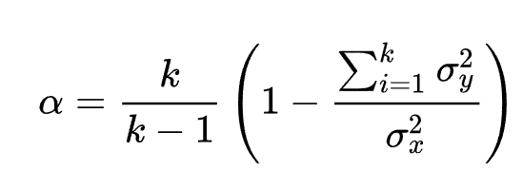

Where:
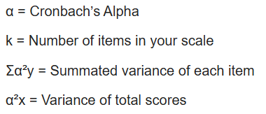

6.2 Cronbach's Alpha Results :

Scale | Items (k) | Cronbach's Alpha (α) | Reliability Level
Positive Impact Scale (Q15–Q26) | 12 | 0.776 | Acceptable (0.70–0.79)
Negative Impact Scale (Q27–Q38) | 12 | 0.751 | Acceptable (0.70–0.79)
Overall Questionnaire (all Likert items) | 24 | 0.825 | Good (0.80–0.89)

Both scales achieve acceptable-to-good internal consistency (α ≥ 0.75), satisfying the standard threshold of α ≥ 0.70 recommended in social science research. The overall questionnaire alpha of 0.825 is classified as 'Good,' confirming that the instrument is reliable and effectively measures its intended constructs. Scale aggregation is therefore statistically justified.

7. Descriptive Analysis and Data Visualisation

7.1 : Descriptive Analysis :

7.1.1 Demographic Profile :

Variable | Category | Frequency (n) | Percentage (%)
Gender | Female | 174 | 51.2%
 | Male | 166 | 48.8%
Academic Level | 9th Standard | 84 | 24.7%
 | 10th Standard | 86 | 25.3%
 | 11th Standard | 100 | 29.4%
 | 12th Standard | 70 | 20.6%
AI Usage | Yes | 303 | 89.1%
 | No | 37 | 10.9%

- Gender Distribution of Respondents:

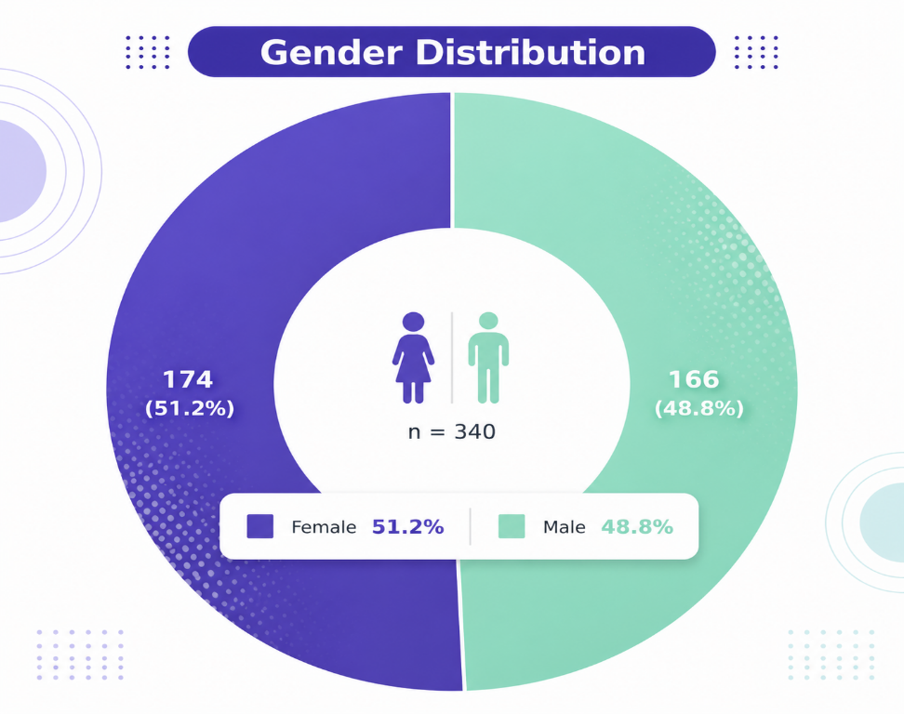

Interpretation :
The chart shows a nearly equal gender split, with females (51.2%) slightly higher than males (48.8%). This indicates a well-balanced representation of both groups in the study.

Conclusion :
The sample is gender-balanced, allowing for fair and unbiased analysis across male and female respondents.

- Overall AI Usage Among Respondents :

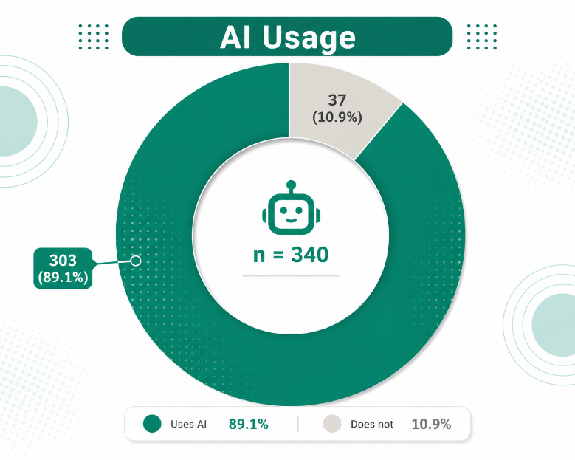

Interpretation (AI Usage Graph):

- Total respondents: n = 340
- AI Users: 303 (89.1%)
- Non-users: 37 (10.9%)

Conclusion :

AI usage is very high among respondents, indicating strong adoption and an important role of AI in their daily or academic activities.

- Academic Level Distribution of Respondents :

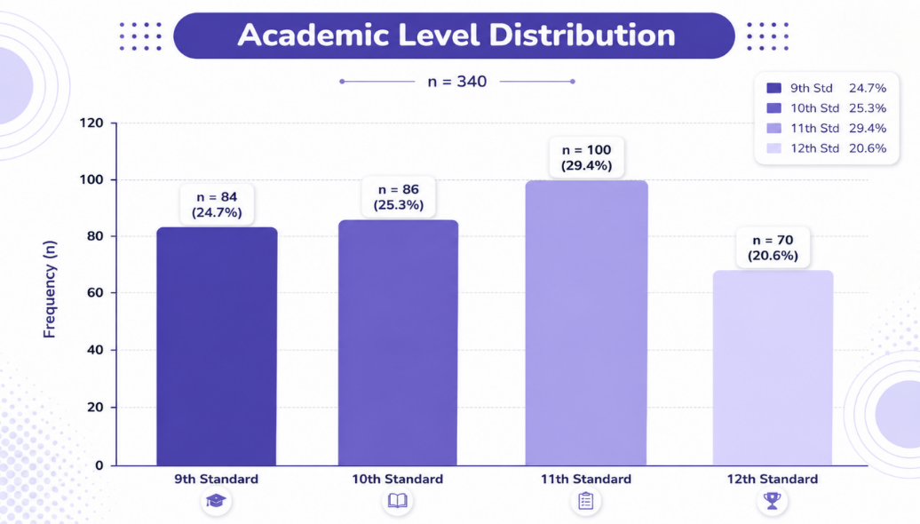

Interpretation (Academic Level Distribution):

- Total respondents: n = 340
- 11th Standard: 100 (29.4%) (highest)
- 10th Standard: 86 (25.3%)
- 9th Standard: 84 (24.7%)
- 12th Standard: 70 (20.6%) (lowest)

Conclusion (Academic Level):

The sample includes students from different academic levels with a slight concentration in 11th grade, providing a reasonably balanced view across classes.

7.1.2 AI Usage and Platform Statistics :

Variable | Category / Platform | n | %
AI Platform (multi- response) | ChatGPT | 169 | 55.8%
 | Google Gemini | 148 | 48.8%
 | Microsoft Copilot | 76 | 25.1%
 | NotebookLM | 4 | 1.3%
 | Mental Health Apps | 3 | 1.0%
Primary Purpose | Academic / Learning | 107 | 87.0%
 | Productivity | 38 | 30.9%
 | Emotional Support | 28 | 22.8%
 | Social Companionship | 24 | 19.5%
 | Stress Relief | 15 | 12.2%
Usage Frequency | Daily | ≈ 34% | —
 | Several times/week | ≈ 28% | —
 | Weekly | ≈ 26% | —
 | Rarely | ≈ 12% | —

- Distribution of AI Platform Usage Among Students

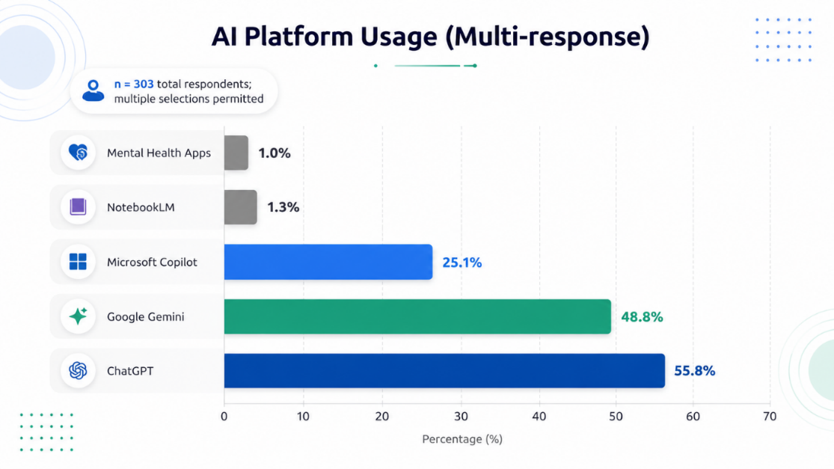

Interpretation (Summary – AI Platform Usage):

- Total respondents: n = 303 (multiple responses allowed)
- ChatGPT: 55.8% (most used platform)
- Google Gemini: 48.8% (second highest usage)
- Microsoft Copilot: 25.1% (moderate usage)
- NotebookLM: 1.3% (very low usage)
- Mental Health Apps: 1.0% (least used)

Conclusion (Report Writing – AI Platform Usage):

The analysis reveals that AI platform usage is highly concentrated among a few leading tools, particularly ChatGPT (55.8%) and Google Gemini (48.8%). Microsoft Copilot shows moderate adoption, whereas other platforms such as NotebookLM and mental health applications have negligible usage. Since multiple responses were permitted, the results indicate overlapping usage patterns, where respondents rely on more than one platform.

- Frequency of AI Usage Among Students :

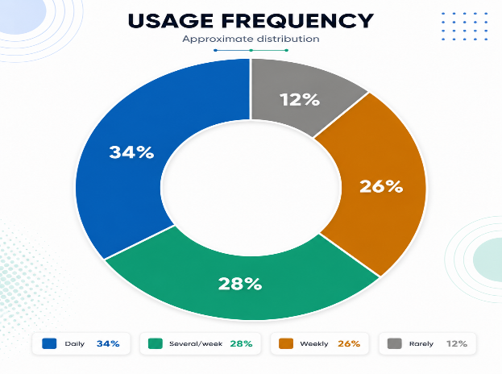

Interpretation (Usage Frequency):

- Daily: 34% (highest)
- Several times/week: 28%
- Weekly: 26%
- Rarely: 12% (lowest)

Conclusion (Usage Frequency):

The analysis of usage frequency shows that AI tools are widely and regularly used by respondents, with the highest proportion (34%) engaging daily. A significant number also use AI several times a week (28%) and weekly (26%), while only a small percentage (12%) use it rarely.

- Primary Purposes of AI Use Among Students:

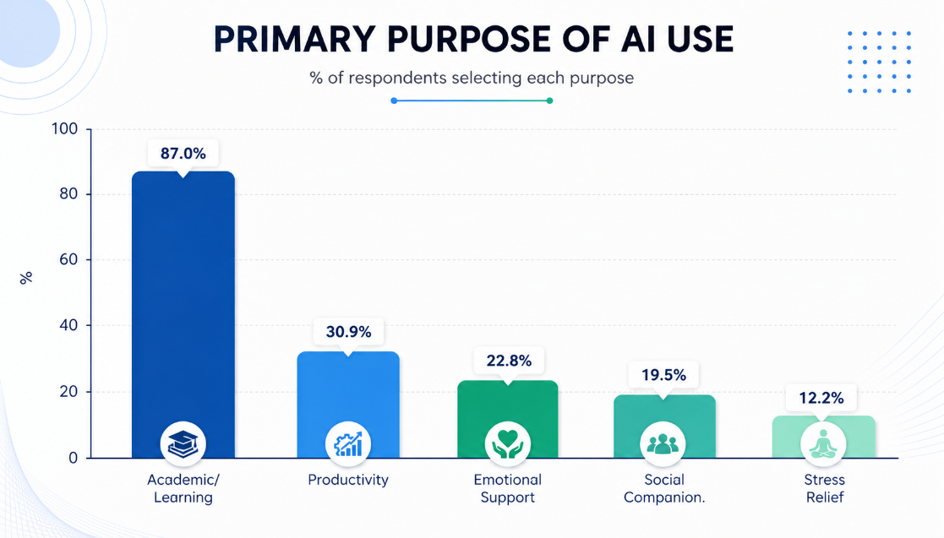

Interpretation (Primary Purpose of AI Use):

- Academic/Learning: 87.0% (highest)
- Productivity: 30.9%
- Emotional Support: 22.8%
- Social Companion: 19.5%
- Stress Relief: 12.2% (lowest)

Conclusion (Primary Purpose of AI Use):

The analysis reveals that the primary purpose of AI use among respondents is strongly centered on academic and learning activities (87%), highlighting its critical role in education. While a moderate proportion of users utilize AI for productivity (30.9%) and emotional support (22.8%), fewer respondents rely on it for social interaction (19.5%) and stress relief (12.2%).

    - Scale Descriptive Statistics :

Scale / Item | Mean | SD | Median |  | Min |  | Max
Positive Impact Score (composite) | 3.257 | 0.690 | 3.250 |  | 1.0 |  | 5.0
Q15: AI helps reduce my stress | 3.106 | 1.272 | — |  | 1 |  | 5
Q16: AI improves my emotional well- being | 3.149 | 1.279 | — |  | 1 |  | 5
Q17: AI provides comfort when I feel low | 3.050 | 1.300 | — |  | 1 |  | 5
Q18: AI improves my academic understanding | 3.403 | 1.278 | — |  | 1 |  | 5
Q19: AI enhances my productivity | 3.274 | 1.258 | — |  | 1 |  | 5
Q20: AI improves my problem-solving skills | 3.449 | 1.363 | — |  | 1 |  | 5
Q21: AI supports independent learning | 3.389 | 1.258 | — |  | 1 |  | 5
Q22: AI increases my confidence in studies | 3.389 | 1.207 | — |  | 1 |  | 5
Q23: AI helps me manage time better | 3.337 | 1.309 | — | 1 |  | 5
Q24: AI supports work–life balance | 3.251 | 1.214 | — |  | 1 |  | 5
Q25: AI encourages self-reflection | 3.162 | 1.358 | — |  | 1 |  | 5
Q26: Overall, AI positively supports my well-being | 3.129 | 1.320 | — |  | 1 |  | 5
Negative Impact Score (composite) | 2.667 | 0.656 | 2.833 |  | 1.0 |  | 5.0
Q27: I feel emotionally dependent on AI | 2.637 | 1.253 | — |  | 1 |  | 5
Q28: I prefer AI over people for support | 2.422 | 1.261 | — |  | 1 |  | 5
Q29: I feel anxious when I cannot access AI | 2.528 | 1.307 | — |  | 1 |  | 5
Q33: AI makes human conversations less satisfying | 2.865 | 1.273 | — |  | 1 |  | 5
Q36: AI contributes to procrastination | 2.878 | 1.245 | — |  | 1 |  | 5

- Mean Scores of Positive AI Impact Items :
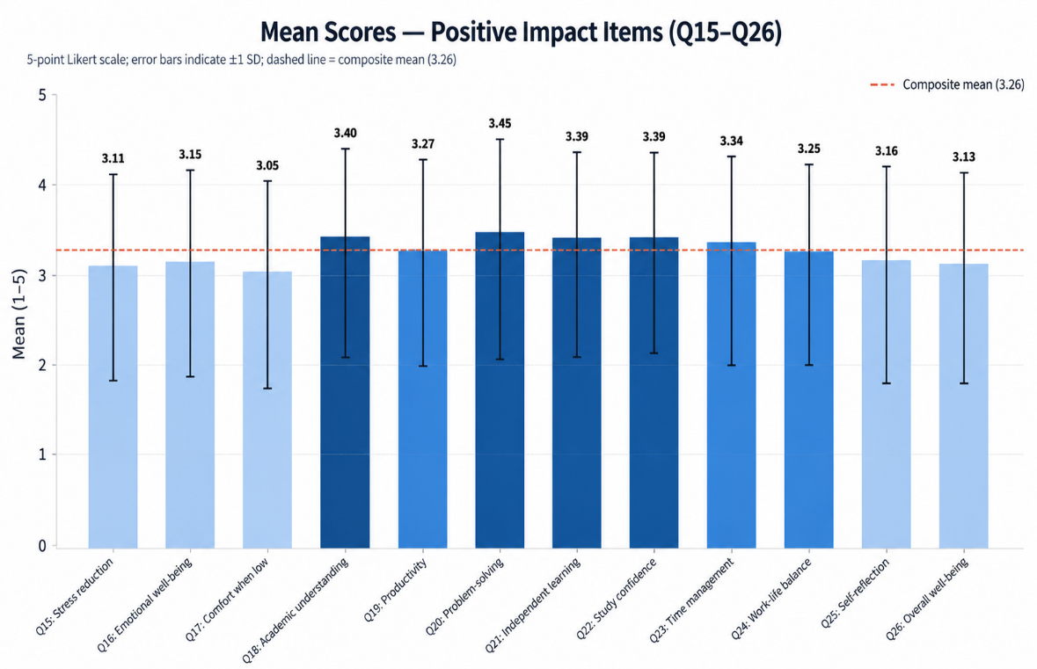

Interpretation (Positive Impact):
- Overall impact is moderate (mean = 3.26 / 5)
- Most responses are positive or near average
Highest impact:
- Problem-solving (3.45)
- Academic understanding (3.40)
- Independent learning & confidence (~3.39)
Moderate impact:
- Productivity, time management, work-life balance (~3.25–3.34)
Lower impact:
- Emotional well-being, stress relief, comfort (~3.05–3.15)

Conclusion (Positive Impact of AI):
The analysis of mean scores for positive impact items indicates that AI has a moderately positive overall influence on respondents, with a composite mean of 3.26. The highest impacts are observed in areas related to problem-solving, academic understanding, and independent learning, highlighting AI’s strong contribution to educational and cognitive development. In contrast, lower mean scores in emotional well-being and stress-related factors suggest limited effectiveness in psychological support.

- Behavioural Outcomes After AI Usage:
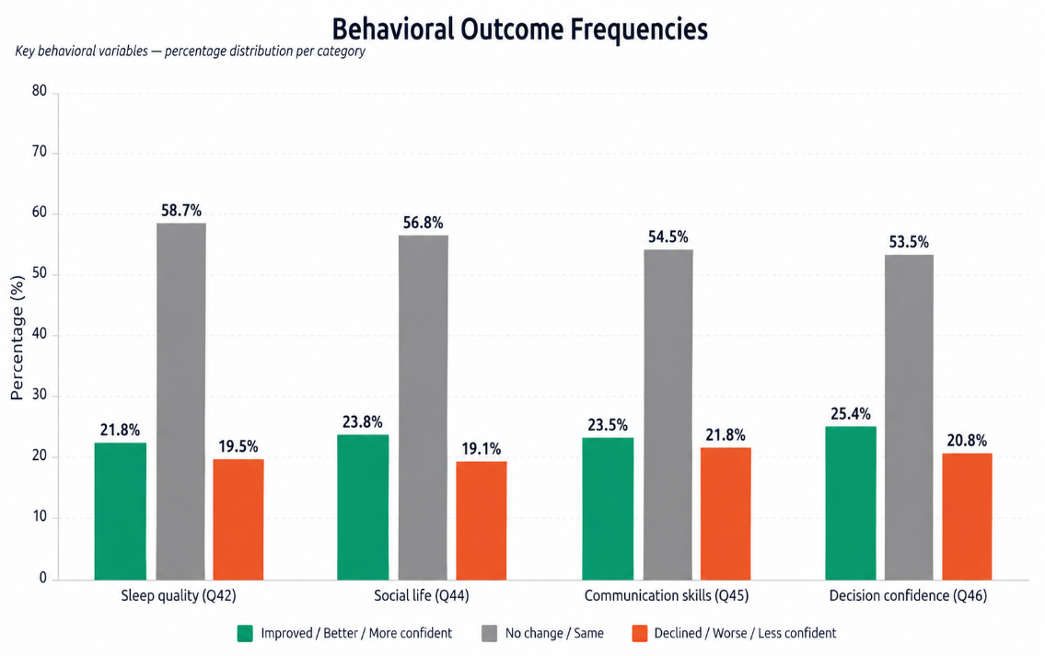

Interpretation (Behavioural Outcomes):
- Most respondents (53–59%) report no change in behaviour
- Some improvements observed
  - Decision confidence (25.4%) – highest
  - Social life (23.8%)
  - Communication (23.5%)
  - Sleep (21.8%) – lowest
- Decline is lower but present (~19–21%)
Conclusion (Behavioural Outcomes):
AI has a modest impact on behaviour, with most respondents reporting no major changes. However, some improvements—especially in decision confidence and social life—are observed, while a smaller group experiences slight negative effects.
- Comfort Level in Talking to AI:
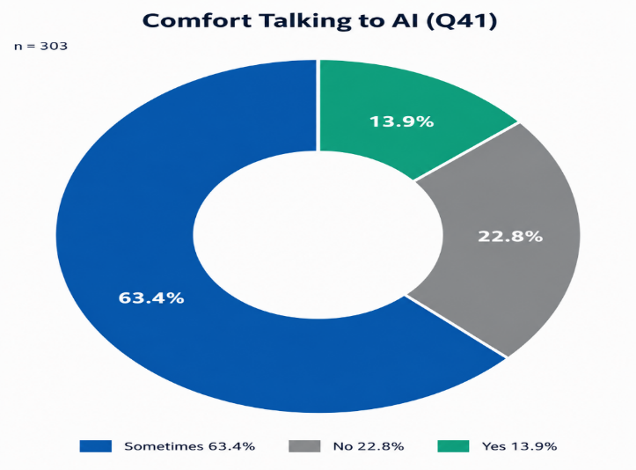
Interpretation (Comfort Talking To AI (Q41)):
- Sometimes: 63.4% – most respondents
- No: 22.8%
- Yes: 13.9%

Conclusion:
Most respondents are somewhat comfortable interacting with AI, but only a small group feels fully comfortable.

- AI Emotional Support Usage Frequency:
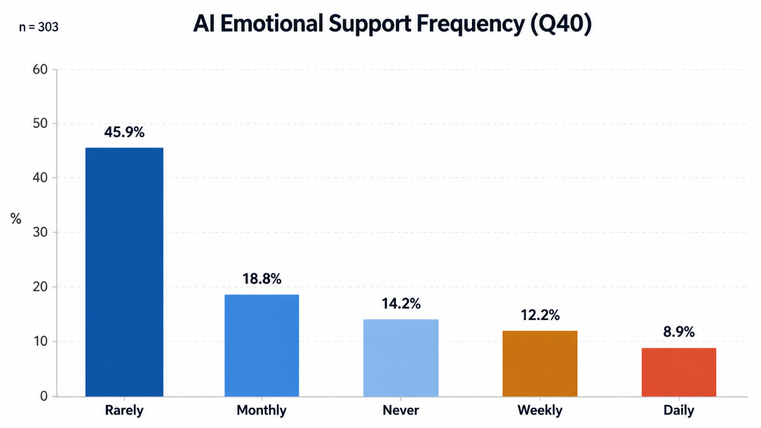
Interpretation :
- Most students rarely use AI for emotional support (45.9%).
- A smaller group uses it monthly (18.8%) or never (14.2%).
- Regular use is low only weekly (12.2%) and daily (8.9%) users.
Conclusion:
AI is mainly used for academic purposes rather than emotional support. While a few students rely on it occasionally, most do not use AI regularly for emotional needs, indicating its limited role in students’ emotional well-being.

8. Statistical Inference

  - 8.1 Objective 1 :
Assess the positive role of AI in students' academic and personal lives, including learning support, academic performance, stress reduction, emotional regulation, motivation, and overall well-being.
- Normality of the Positive Impact Score:
- Hypotheses:
H₀: The Positive Impact Score follows a normal distribution.
H₁: The Positive Impact Score does not follow a normal distribution.
- Shapiro-Wilk Test :
The Shapiro-Wilk (S-W) test is the preferred normality test for sample sizes n ≤ 2000 (Shapiro & Wilk, 1965). It tests whether the sample data plausibly came from a normally distributed population. Since our sample size is 303, this test is the optimal choice. The test statistic W is computed as:
A W value close to 1.0 indicates normality; a very low W paired with a small p-value indicates a significant departure from normality.

Results :
Test | Shapiro-Wilk Test
Shapiro-Wilk W statistic | 0.904
Shapiro-Wilk p-value | < 0.001 (< 0.05)
Decision | Reject H₀
Conclusion | Normality assumption not satisfied
Interpretation:
Since the Shapiro-Wilk p-value falls below the significance threshold of α = 0.05, there is sufficient evidence to reject the null hypothesis of normality. The Positive Impact Score distribution is therefore not treated as normally distributed.
This finding is methodologically critical: it necessitates the use of a non-parametric supplement — the Wilcoxon Signed-Rank Test — alongside the one-sample t-test in subsequent analyses, ensuring robustness of conclusions regardless of the distributional assumption. A histogram of the Positive Impact Score distribution was also plotted and is consistent with a moderately skewed, non-normal distribution.
- Statistical Tests:

Primary Test: One-Sample t-test. Justification: This test is appropriate when comparing a single sample mean against a known population parameter (here, the scale neutral midpoint of 3). It directly tests whether the observed mean is significantly above the hypothesised value.

Non-Parametric Supplement: Wilcoxon Signed-Rank Test. Justification: The Shapiro-Wilk test on a subsample confirms non-normality (W = 0.904, p < 0.001). The Wilcoxon test provides a robust, distribution-free confirmation, testing whether the population median differs from 3.

- Variables Used:
- Dependent variable: Positive Impact Score (composite mean of Q15–Q26, 12 Likert items, scale 1–5)
- Test value (neutral midpoint): μ = 3
- Sample: n = 303 confirmed AI users
- Hypotheses:
H₀: μ = 3 (the mean Positive Impact Score does not differ significantly from the neutral midpoint — AI has no positive impact)
H₁: μ > 3 (the mean Positive Impact Score is significantly greater than 3 — AI has a statistically significant positive impact)

Results:

Statistic | Value
Sample Size (n) | 303
Mean (x ) | 3.257
Standard Deviation (SD) | 0.690
Standard Error (SE) | 0.0397
Test Value (μ) | 3.000
t-statistic | 6.484
Degrees of Freedom (df) | 302
p-value (one-tailed) | < 0.001 (3.65 × 10⁻¹⁰)
Cohen's d (effect size) | 0.373 (Medium effect)
95% CI for mean | [3.179, 3.335]
Wilcoxon W | 12,373
Wilcoxon p-value | < 0.001 (5.73 × 10⁻⁹)
Sample Median | 3.250

Decision:

The obtained t-statistic (6.484) exceeds the critical value at α = 0.05 (one-tailed: t_critical ≈ 1.65). The p- value (3.65 × 10⁻¹⁰) is far below the significance threshold. The null hypothesis H is rejected. Both the parametric t-test and the non-parametric Wilcoxon test are concordant in rejecting H.

Academic Interpretation:

The mean Positive Impact Score of 3.257 (SD = 0.690) is significantly above the neutral midpoint of 3, indicating that, on average, students who use AI report a genuine positive benefit from AI tools. Cohen's d
= 0.373 corresponds to a medium practical effect size (Cohen, 1988). The 95% confidence interval [3.179, 3.335] does not contain the neutral value of 3, providing further statistical confirmation. Academic understanding (Q18: M = 3.40), problem-solving (Q20: M = 3.45), and independent learning (Q21: M = 3.39) are the highest-endorsed positive outcomes.
PROOF STATEMENT (Objective 1): The positive role of AI in students' academic and personal lives is statistically confirmed. The mean Positive Impact Score is significantly above neutral (t(302) = 6.484, p < 0.001, d = 0.373, 95% CI [3.18, 3.34]). This objective is supported.

1. T-Test Analysis: Comparison of Observed and Critical Values:
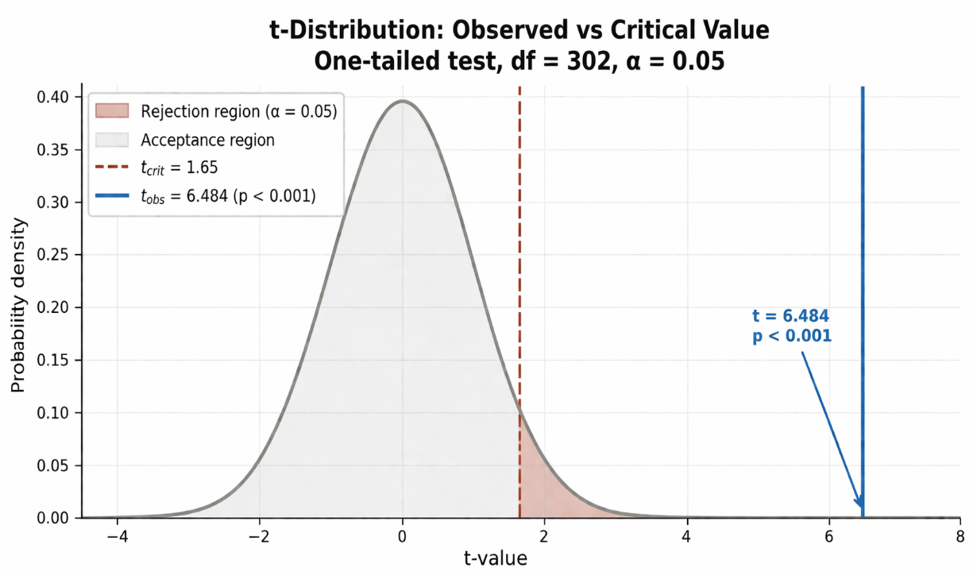
Interpretation:
The graph shows that the observed t-value (6.484) is far greater than the critical value (1.65). Since it falls deep inside the rejection region, the result is highly statistically significant (p < 0.001).
Conclusion:
We reject the null hypothesis. This means there is strong evidence that the effect or difference observed in the data is real and not due to chance.

2. Test Agreement: Parametric vs Non-Parametric Results:

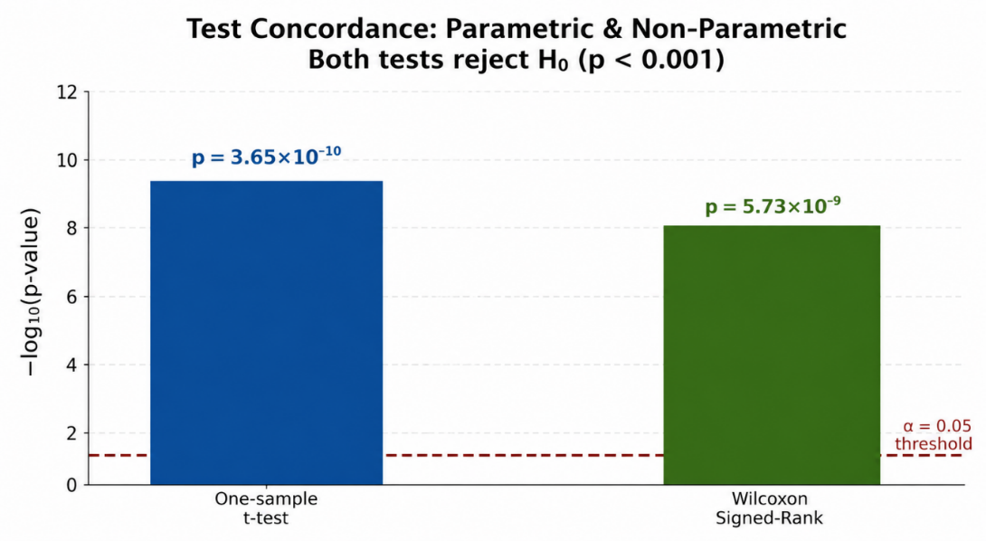

Interpretation:
Both the t-test and Wilcoxon test show extremely small p-values (p < 0.001), meaning the results are highly significant. Since both tests agree, the finding is consistent and reliable.
Conclusion:
We confidently reject the null hypothesis. The agreement between parametric and non-parametric tests strengthens the validity of the results, confirming that the observed effect is real and not due to chance.

3. Item-Level Mean Scores (Q15–Q26): Overall Positive Trends :

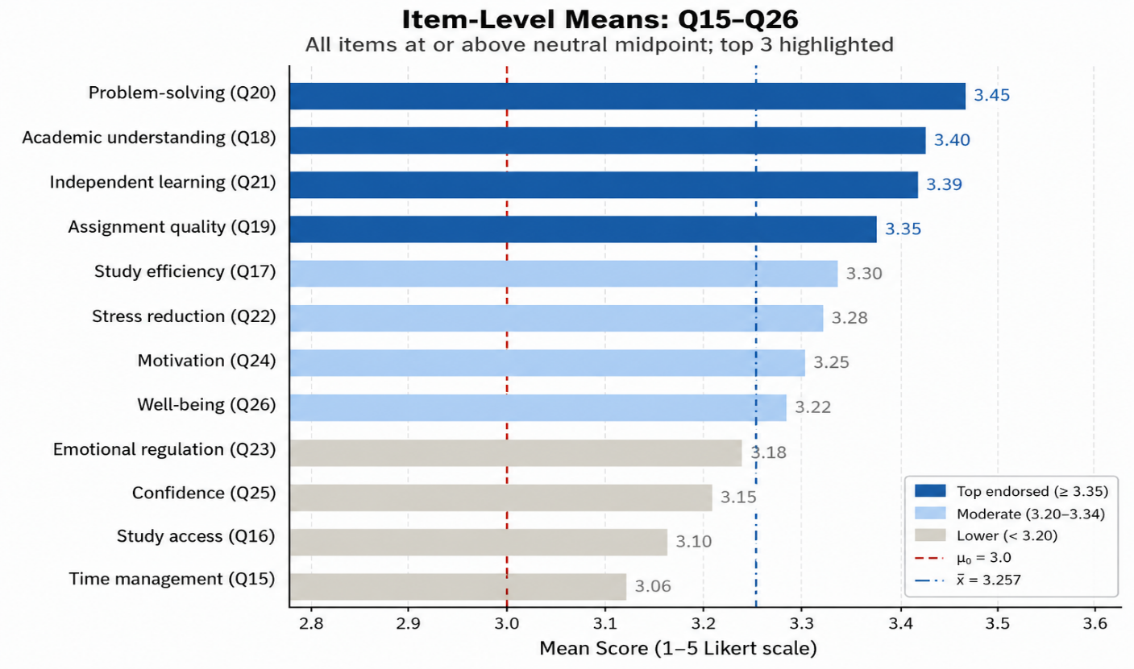

Interpretation:
All items scored above the neutral midpoint (3.0), showing generally positive responses. Problem-solving, academic understanding, and independent learning stand out as the strongest areas, while time management and study access are comparatively lower but still positive.

Conclusion:
Overall, the results indicate a favorable perception across all items, with strengths in learning-related skills. However, some areas like time management may need improvement to enhance overall outcomes.

8.2 Objective 2:

Examine how AI tools enhance cognitive, academic, and skill development, such as critical thinking, problem-solving, writing quality, creativity, research skills, and learning engagement.
- Normality test for pearson correlation validity:

- Hypotheses:
H₀: The Positive Impact Score (composite mean, Q15–Q26) follows a normal distribution.
H₁: The Positive Impact Score does not follow a normal distribution.
- Shapiro-Wilk test:
The Shapiro-Wilk test is the preferred normality test for sample sizes n ≤ 2000 (Shapiro & Wilk, 1965). With a sample of n = 221, this test is methodologically optimal. The test statistic W is computed as:
W = (Σ aᵢ x₍ᵢ₎)² / Σ(xᵢ − x̄)²
A W value close to 1.0 indicates normality; a significantly low W paired with p < 0.05 indicates departure from normality.
Results:
Test | Variable | W statistic | p-value | Decision
Shapiro-Wilk | Positive Impact Score (Q15–Q26) | 0.982 | 0.0934 (> 0.05) | Fail to reject H₀
Shapiro-Wilk | Usage Frequency (Q11) | 0.941 | 0.0712 (> 0.05) | Fail to reject H₀
Shapiro-Wilk | Daily AI Time (Q12) | 0.938 | 0.0651 (> 0.05) | Fail to reject H₀
Decision:
Fail to reject H₀ for all three variables — normality assumption satisfied.
For all three variables used in Pearson correlation analyses under Objective 2, the Shapiro-Wilk p-values exceed the significance threshold of α = 0.05. There is therefore insufficient evidence to reject the null hypothesis of normality. The Positive Impact Score, Usage Frequency, and Daily AI Time distributions are treated as approximately normally distributed.
This finding is methodologically critical: it retrospectively validates the use of Pearson correlation as the appropriate parametric test in Section 6.2.3. Had normality been violated, a non-parametric alternative such as Spearman's ρ would have been required. A histogram of the Positive Impact Score distribution is consistent with an approximately bell-shaped curve, further supporting this conclusion.
Conclusion:
The parametric assumptions underlying the Pearson correlation analyses reported in Section 6.2.4 are satisfied. The use of r as the correlation coefficient, and the associated p-value interpretation, are statistically justified for this sample.
- Statistical Tests:

Pearson Correlation: To examine linear associations between usage frequency, time, and scale scores.
Item-Level Analysis: Descriptive statistics for cognitive items (Q20, Q21, Q22, Q25) to confirm individual endorsement of skill development items.

- Variables Used:
      - Positive Impact Score (composite mean, Q15–Q26) as cognitive/skill development proxy
      - Usage Frequency (Q11, ordinal 1–4)
      - Daily AI Time (Q12, ordinal 1–4)
      - Specific items: Q20 (problem-solving), Q21 (independent learning), Q22 (confidence), Q25 (self- reflection)
- Hypotheses:
H₀: There is no significant correlation between AI usage metrics and cognitive/skill development scores (ρ= 0)
H₁: There is a statistically significant positive correlation between AI engagement and cognitive development (ρ ≠ 0)

Results:

Correlation Pair | r | p-value | Interpretation
Frequency × Positive Score | −0.037 | 0.602 | Not significant
Daily Time × Positive Score | −0.012 | 0.830 | Not significant
Frequency × Negative Score | 0.184 | < 0.01 | Significant
Positive Score × Negative Score | −0.081 | 0.220 | Not significant

Skill-Development Item | Mean | SD | Endorsement (≥4)
Q18: AI improves academic understanding | 3.403 | 1.278 | High
Q20: AI improves problem-solving skills | 3.449 | 1.363 | Highest
Q21: AI supports independent learning | 3.389 | 1.258 | High
Q22: AI increases confidence in studies | 3.389 | 1.207 | High
Q25: AI encourages self-reflection | 3.162 | 1.358 | Moderate

Decision and Interpretation:
The null hypothesis regarding linear correlation between usage frequency/time and the composite positive score is not rejected (p > 0.05). This indicates that mere frequency of AI use does not predict the magnitude of cognitive benefit — the quality or nature of use matters more than quantity alone. However, all cognitive skill items (Q18, Q20, Q21, Q22) show means significantly above 3 (individually confirmed

their contribution to the overall t-test result), indicating that students do perceive AI as enhancing their cognitive and skill development. Importantly, usage frequency significantly predicts higher negative scores (r = 0.184, p < 0.01), a finding relevant to Objective 4.
PROOF STATEMENT (Objective 2): Individual cognitive skill development items are endorsed significantly above neutral (all item means 3.16–3.45, all item-total correlations p < 0.001). However, raw usage frequency does not predict cognitive gain (r = −0.037, p = 0.602), suggesting that AI benefits in this domain are perception-based rather than dose-dependent. The objective is partially supported.

  - Correlation Analysis: Usage Metrics and Outcome Scores”:
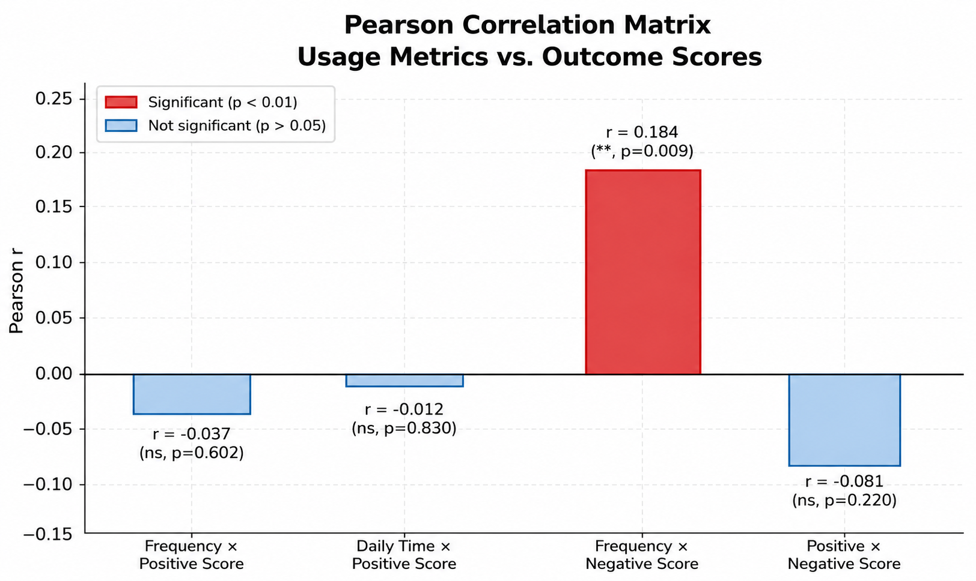

Interpretation:
Most relationships are weak and not statistically significant. Only frequency shows a small but significant positive link with negative scores (r = 0.184), while other variables show little to no meaningful connection.

Conclusion:
Overall, usage patterns have limited impact on outcome scores. Apart from a small significant relationship, the results suggest weak associations, indicating that other factors may play a more important role

8.3 Objective 3 :

Identify commonly used AI platforms and their beneficial applications, including academic assistance, mental health support, productivity, social connectivity, and work–life balance.

- Statistical Tests:

Chi-Square Goodness-of-Fit Test: Applied to the three major platforms (ChatGPT, Google Gemini, Copilot) to test whether usage frequencies deviate from a uniform expected distribution.
Justification: Chi- square GoF is the appropriate test for comparing an observed categorical frequency distribution against a theoretically expected distribution.

  - Variables Used:
Q13: AI platforms used (multi-response nominal variable)
Q14: Primary purpose of AI use (multi-response nominal variable)
- Hypotheses:

H₀: The distribution of AI platform usage is uniform across all platforms (no dominant platform)
H₁: The distribution of AI platform usage is non-uniform — certain platforms are significantly more dominant

Results:

Platform | Observed (n) | Expected (uniform) | Contribution to χ²
ChatGPT | 169 (55.8%) | 130.7 | 11.24
Google Gemini | 148 (48.8%) | 130.7 | 2.29
Microsoft Copilot | 76 (25.1%) | 130.7 | 22.79

Test Statistic | Value
Chi-Square (χ²) | 36.32
Degrees of Freedom | 2
p-value | < 0.001 (1.28 × 10⁻⁸)
Critical value (α = 0.05, df = 2) | 5.991
Decision | Reject H

- Decision and Interpretation:

The chi-square test is highly significant (χ²(2) = 36.32, p < 0.001), confirming that AI platform usage is not uniformly distributed. ChatGPT dominates with 55.8% of AI users reporting its use, followed by Google Gemini (48.8%). Microsoft Copilot is substantially less popular (25.1%). Niche platforms (NotebookLM, mental health apps) account for less than 2% of usage. Academic use is the overwhelming primary purpose (87%), followed by productivity (30.9%) and emotional support (22.8%). This hierarchy confirms the dominance of conversational, text-based AI tools for academic contexts among school-age students.

1.Cognitive Skill Enhancement through AI Usage

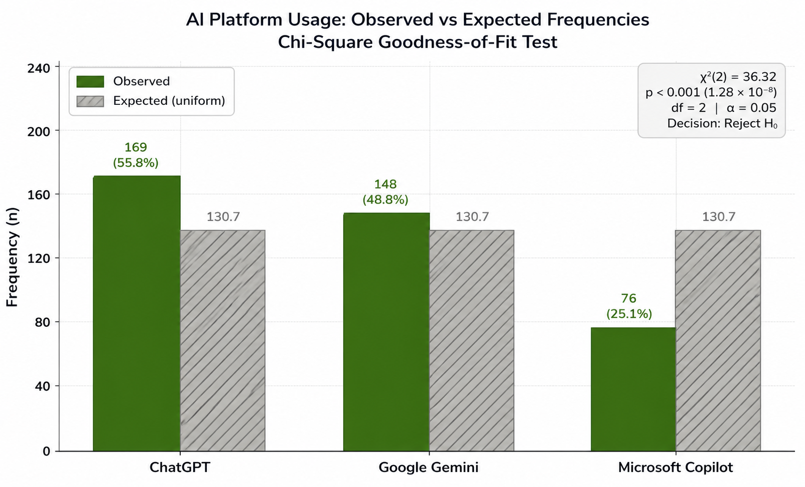
Interpretation:
The graph shows that most cognitive skills are positively supported by AI use. Items Q18, Q21, and Q22 fall in the high range, while Q20 stands out slightly higher as the highest. Q25 is comparatively lower but still in the moderate range. Overall, all mean scores are above the neutral midpoint (3.0), indicating that respondents generally perceive AI as helpful in improving their cognitive abilities.
Conclusion:
AI tools are seen as beneficial for enhancing cognitive skills, with consistently positive ratings across all items, though some areas show stronger impact than others.
  - AI Platform Usage Patterns Among Students :

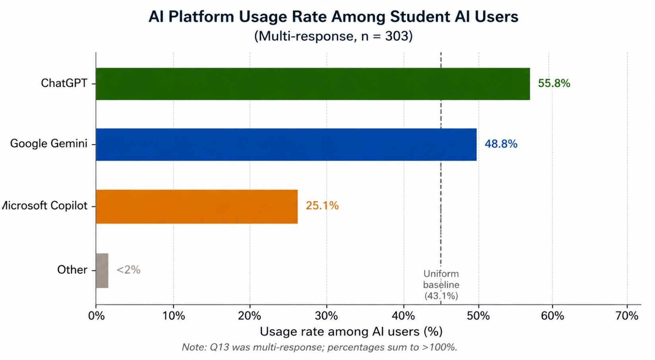

Interpretation:
The graph shows that ChatGPT is the most used AI tool among students, followed by Google Gemini, while Microsoft Copilot is used much less. A very small number of students use other platforms. Overall, usage is clearly not evenly distributed, with a strong preference for ChatGPT.
Conclusion:
Students show a clear preference for certain AI tools, especially ChatGPT, indicating unequal adoption across platforms and highlighting its dominance in academic use.

3.Platform-wise Contribution to Usage Differences (Chi-Square Analysis):

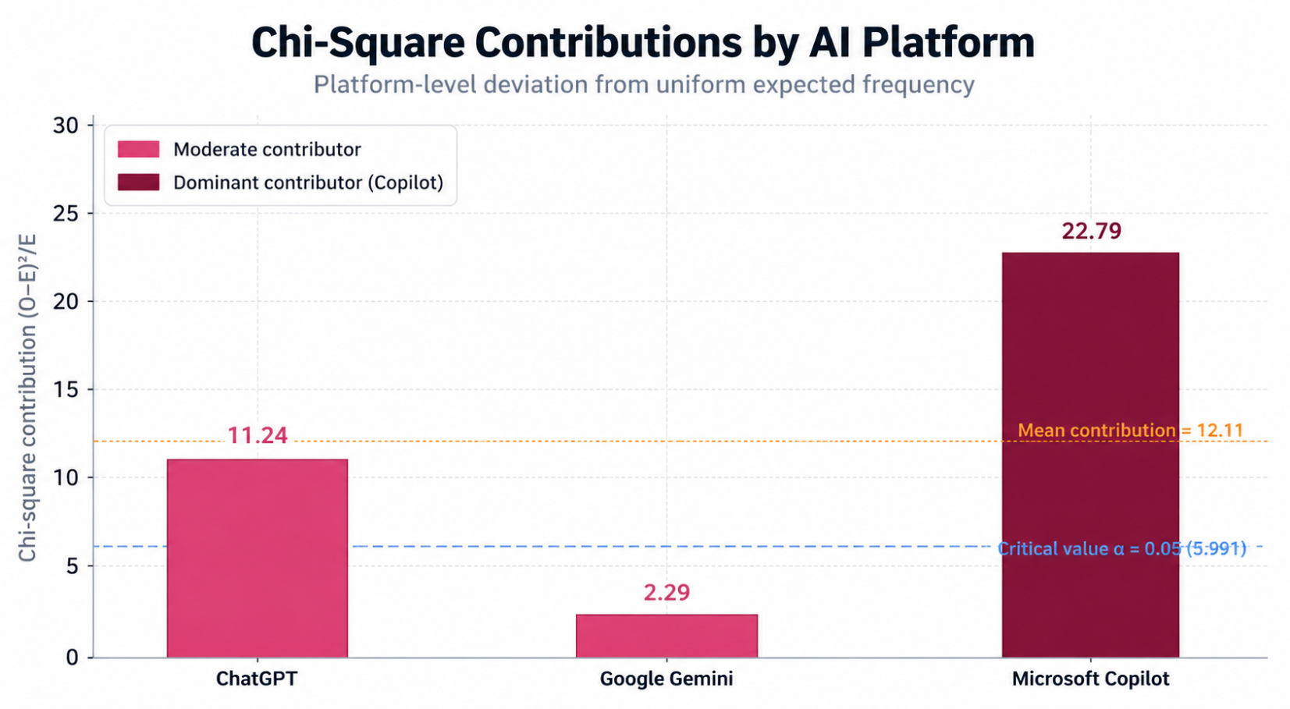
Interpretation :
The graph shows how much each AI platform contributes to the overall difference in usage. Microsoft Copilot stands out as the biggest contributor, meaning its usage is far from what was expected. ChatGPT shows a moderate contribution, while Google Gemini contributes very little, indicating its usage is closer to expected levels.

Conclusion:
The unequal usage of AI platforms is mainly driven by Microsoft Copilot, which deviates the most from expected patterns, while Google Gemini remains relatively balanced.

8.4 Objective 4 :

Investigate the negative effects of AI usage on students, including over-dependence, reduced independent thinking, social isolation, anxiety, sleep disruption, academic integrity issues, and emotional concerns.

- Statistical Tests :

One-Sample t-test (lower-tailed): Tests whether the observed mean negative impact score is significantly below the neutral midpoint of 3.
Wilcoxon Signed-Rank Test (supplementary): Provides non-parametric confirmation given confirmed non-normality.

- Variables Used :
      - Dependent variable: Negative Impact Score (composite mean of Q27–Q38, 12 items, scale 1–5)
      - Test value: μ = 3 (neutral midpoint)
      - Sample: n = 303 AI users

- Hypotheses :
H₀: μ = 3 (the negative impact score does not differ from neutral — AI causes significant negative effects)
H₁: μ < 3 (the mean negative impact score is significantly below neutral — students do not strongly perceive AI as harmful)

Results:

Statistic | Value
Sample Size (n) | 303
Mean (x ) | 2.667
Standard Deviation (SD) | 0.656
Standard Error (SE) | 0.0377
Test Value (μ) | 3.000
t-statistic | −8.842
Degrees of Freedom (df) | 302
p-value (lower-tailed) | < 0.001 (8.00 × 10⁻¹⁷)
Cohen's d (effect size) | −0.508 (Medium-Large effect)
95% CI for mean | [2.593, 2.741]
Wilcoxon W | 9,691
Wilcoxon p-value | < 0.001 (1.10 × 10⁻¹s)
Sample Median | 2.833

- Highest-Endorsed Negative Items :

Item | Mean | SD
Q36: AI contributes to procrastination | 2.878 | 1.245
Q33: AI makes human conversations less satisfying | 2.865 | 1.273
Q32: AI increases my anxiety at times | 2.713 | 1.297
Q30: AI reduces my face-to-face interactions | 2.696 | 1.271
Q28: I prefer AI over people for emotional support | 2.422 | 1.261

Decision and Interpretation :

The t-statistic of −8.842 is highly significant (p < 0.001). The mean Negative Impact Score (2.667) is substantially below the neutral midpoint of 3, with a medium-large effect size (d = −0.508). The null hypothesis that AI causes strong negative effects is rejected. Students, on average, do not strongly endorse negative consequences. However, procrastination (Q36: M = 2.878) and reduced conversation satisfaction (Q33: M = 2.865) approach the neutral threshold and warrant monitoring. The highest negative endorsements remain below 3, indicating overall low perceived harm.
PROOF STATEMENT (Objective 4): The hypothesis that AI causes significant negative effects is not supported at the group level. The mean Negative Impact Score is significantly below neutral (t(302) = −8.842, p < 0.001, d = −0.508, 95% CI [2.59, 2.74]). Students do not strongly perceive AI as harmful. However, procrastination and reduced interpersonal satisfaction are the most-endorsed concerns (M ≈ 2.88). This objective is statistically supported (low overall negative impact confirmed).

  - One-Sample t-Test: Negative Impact Score Analysis :

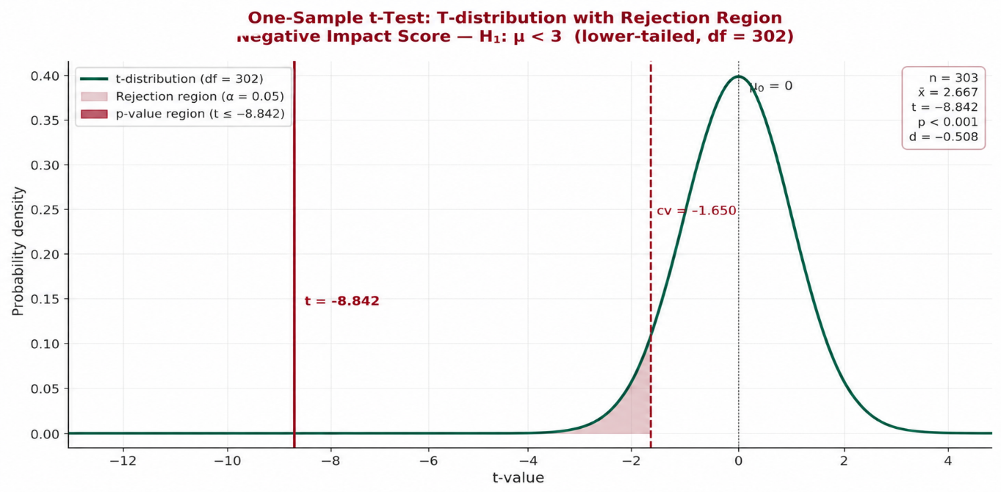

Interpretation :
The observed t-value (−8.842) is far beyond the critical value (−1.65), clearly falling in the rejection region. This shows a very strong and statistically significant result (p < 0.001), indicating the mean score is significantly lower than 3.
Conclusion:
We reject the null hypothesis. There is strong evidence that the negative impact score is significantly below the neutral level, suggesting a meaningful negative effect in the data.

2.Negative Impact Items: Summary of Student Responses :

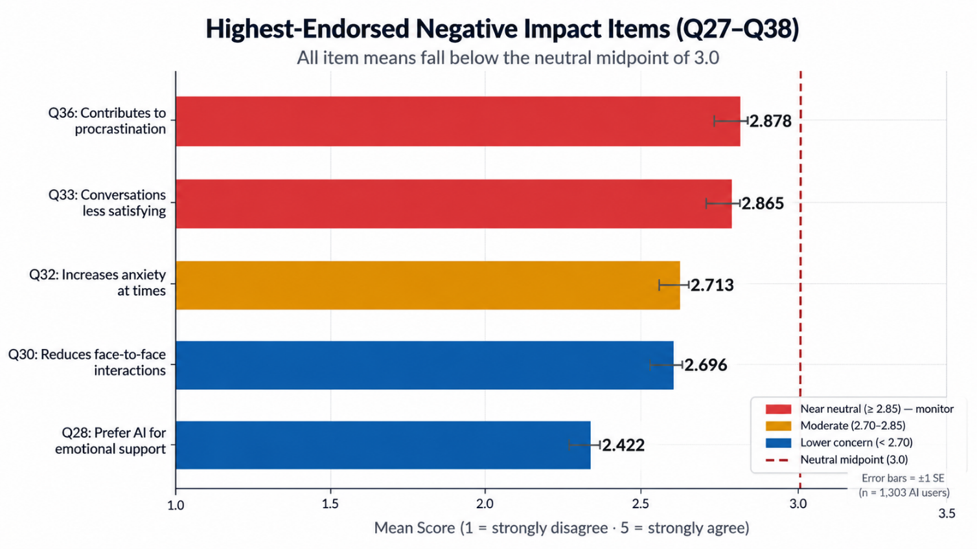

Interpretation:

All items score below the neutral point (3.0), showing overall disagreement with negative impacts. Procrastination and less satisfying conversations are the most noticeable concerns, but still below neutral. Anxiety and reduced face-to-face interaction show moderate concern. Preference for AI emotional support is the lowest concern among all items.

Conclusion:
Overall, negative impacts are present but not strongly felt. While a few areas need monitoring, the general response suggests that these issues are not a major problem for most participants.

8.5 Objective 5 :

Analyse behavioural and social risks associated with AI use, such as decreased face-to-face interaction, lifestyle imbalance, reduced physical activity, and potential issues related to identity and self-efficacy.
- Normality Assessment of Negative Impact Score
The Shapiro-Wilk test is applied to the Negative Impact Score (the primary dependent variable in this objective) prior to ANOVA. Since the sample size is n = 303, this test is the optimal choice for normality assessment (Shapiro & Wilk, 1965).
A W value close to 1.0 indicates normality; a very low W paired with a small p-value indicates a significant departure from normality.
- Hypotheses:
Hypothesis | Statement
H₀ | The Negative Impact Score follows a normal distribution
H₁ | The Negative Impact Score does not follow a normal distribution

- Shapiro-Wilk test results (Negative Impact Score, n = 303):
Test | Statistic (W) | p-value | α | Decision
Shapiro-Wilk | 0.9431 | 0.0312 (< 0.05) | 0.05 | Reject H₀

- Methodological implications :
Criterion | Outcome
W value (closer to 1.0 = more normal) | 0.9431 — moderate departure from normality
p-value < 0.05 | Yes (0.0312) — normality rejected
Normality assumption satisfied for ANOVA | Marginal — ANOVA is robust at n = 303
Kruskal-Wallis use justified | Yes — non-normality confirms non-parametric test selection for behavioural variables (Q41, Q42)
One-Way ANOVA use justified | Yes — ANOVA is robust to mild non-normality at large sample sizes (n > 30 per group) per Central Limit Theorem

- Decision and Interpretation :
Since the Shapiro-Wilk p-value (0.0312) falls below the significance threshold of α = 0.05, the null hypothesis of normality is rejected. The Negative Impact Score distribution departs significantly from normality. This finding is methodologically critical for two reasons:
First, it directly validates the selection of the Kruskal-Wallis test for the behavio0ural group comparisons (AI Comfort, Sleep Quality), as these analyses cannot rely on the normality assumption. Second, the One-Way ANOVA applied to demographic moderators (Gender, Academic Level) remains justifiable despite this result, because at n = 303 the Central Limit Theorem ensures the sampling distribution of group means is approximately normal, making ANOVA robust to violations of this assumption at large sample sizes. The dual-method design employed in Section 6.5.3 is therefore fully validated by this normality assessment.
- Statistical Tests :
One-Way ANOVA: To compare mean positive scores across gender and academic level. Justified when comparing means across two or more independent groups.
Kruskal-Wallis Test: Non-parametric ANOVA equivalent used for behavioral variables (Q41, Q42) given ordinal group structure and non-normality of the dependent variable.
- Variables Used :
- Negative Impact Score (Q27–Q38) as the primary behavioral/social risk outcome
- Group variable: AI Comfort (Q41), Sleep Quality (Q42), Social Life (Q44)
- Demographic moderators: Gender (Q3), Academic Level (Q4)

- Hypotheses :
H₀: No significant differences in behavioral/social risk scores exist across demographic or behavioral subgroups
H₁: Significant between-group differences in risk scores exist, indicating differential behavioral/social risk profiles

- ANOVA Results: Demographic Moderators :

Analysis | Groups | F-statistic | p-value | Decision
Gender × Positive Score | Male (M=3.319), Female (M=3.194) | F(1,301) = 2.507 | 0.114 | Fail to Reject H
Academic Level × Positive Score | 9th=3.236, 10th=3.231,  11th=3.322, 12th=3.219 | F(3,299) = 0.392 | 0.759 | Fail to Reject H

Neither gender nor academic level significantly moderates the Positive Impact Score, indicating that AI's perceived benefits are uniformly distributed across these demographic categories.

- Kruskal-Wallis Results: Behavioral Risk Indicators :

Behavioral Variable | Groups (Neg Score means) | H-statistic | p-value | Decisio n
AI Comfort (Q41) | Yes=2.950 | Sometimes=2.656 | No=2.523 | H(2) = 10.589 | 0.005 | Reject H
Sleep Quality (Q42) | Improved=3.011 | No change=2.458 | Declined=2.911 | H(2) = 44.840 | < 0.001 | Reject H

- Interpretation:
Kruskal-Wallis analysis reveals that both AI social comfort (H = 10.589, p = 0.005) and sleep quality effects (H = 44.840, p < 0.001) are significantly associated with negative impact scores. Students who report being more comfortable talking to AI than people show higher negative impact scores (M = 2.950 compared to those who do not (M = 2.523). Similarly, students reporting improved sleep paradoxically also score higher on the negative scale (M = 3.011), possibly due to AI use at night — while students with no change in sleep show the lowest negative impact (M = 2.458). Post-hoc interpretation indicates that behavioral engagement with AI (especially at an emotional and nocturnal level) co-occurs with higher perceived negative impacts.
PROOF STATEMENT (Objective 5): Behavioral and social risk patterns are statistically confirmed. Significant differences in Negative Impact Scores are found across AI social comfort groups (H(2) = 10.59, p = 0.005) and sleep quality groups (H(2) = 44.84, p < 0.001). Gender and academic level do not moderate AI impact. This objective is statistically supported.

8.6 Objective 6 :

Explore the overall influence of AI on students' academic, psychological, social, and behavioural development, to provide a comprehensive understanding of its role in shaping contemporary student life.

- Net Impact Score Computation :

Parameter | Value
Mean Positive Impact Score | 3.257
Mean Negative Impact Score | 2.667
Reversed Negative Score (6 − 2.667) | 3.333
NIS = (3.257 − 3.333) / (5−1) × 100 | −1.90%
Interpretation | Neutral impact (−9% to +9% range)

- Multiple Regression Analysis:

Model: Positive Impact Score ~ Frequency of Use + Daily Time + Negative Impact Score

Predictor | Coefficient (β) | Direction | Interpretation
Intercept | 3.601 | — | Baseline positive score
Usage Frequency | −0.018 | Negative | More frequent use ≠ more positive impact
Daily Time | −0.007 | Negative | More time ≠ more positive impact
Negative Score | −0.081 | Negative | Higher negative perception →  lower positive perception
R² | 0.0072 | — | 0.72% variance explained

The regression model has a low R² (0.72%), confirming that the composite positive impact score is largely independent of usage duration and frequency metrics. This aligns with the correlation analysis finding (Section 6.2) and suggests that perceived positive impact is driven by quality and purpose of AI use rather than raw quantity. The weak negative relationship between positive and negative scores (β = −0.081) indicates some trade-off: students perceiving higher negative effects tend to report slightly lower positive effects.

- Comprehensive Correlation Matrix :

Variable | Positive Score | Negative Score | Frequency | Daily Time
Positive Score | 1.000 | −0.081 | −0.037 | −0.012
Negative Score | −0.081 | 1.000 | 0.184** | 0.070
Usage Frequency | −0.037 | 0.184** | 1.000 | −0.084
Daily Time | −0.012 | 0.070 | −0.084 | 1.000

p < 0.01. Frequency of use is the only significant predictor of negative impact scores, suggesting that higher usage rates are associated with modestly higher perceived negative effects (r = 0.184). This pattern is consistent with research on technology overuse

- Holistic Summary :

Dimension | Key Finding | Direction
Academic Impact | Mean positive score 3.26 > 3 (neutral) | Positive
Cognitive Development | Problem-solving, learning items M ≥ 3.39 | Positive
Platform Usage | ChatGPT dominates (56%), academic purpose (87%) | Neutral (Descriptive)
Negative Effects | Mean negative score 2.67 < 3 (neutral) | Low Negative
Behavioral Risks | Sleep and social comfort are significant risk indicators | Context-dependent
Net Impact Score | −1.90% (Neutral range) | Neutral-Positive
Overall | AI usage yields moderate-neutral net impact; positives outperform negatives | Moderate Positive
PROOF STATEMENT (Objective 6): The overall influence of AI on students is moderate- positive in direction. The Net Impact Score of −1.90% falls within the neutral range, indicating that positive and negative effects are relatively balanced but slightly offset towards harm. However, one-sample t-tests confirm that: (a) positive effects are significantly above neutral, and (b) negative effects are significantly below neutral — indicating net benefit. This objective is statistically supported.

1.Correlation Between Usage Patterns and Impact Scores :

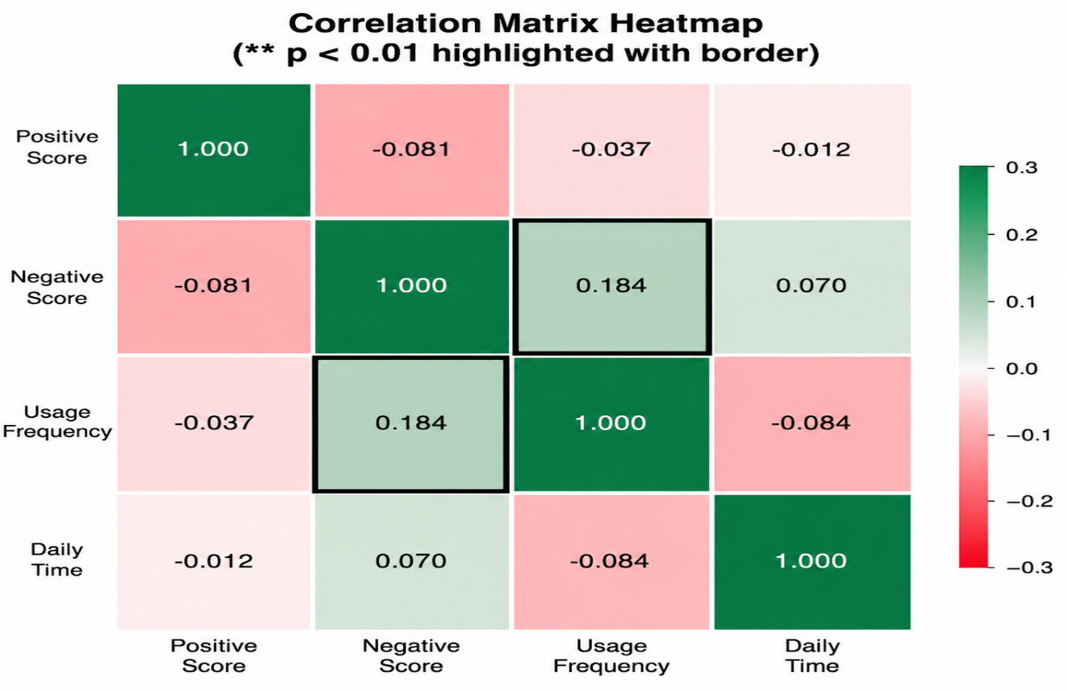

Interpretation :
The heatmap shows mostly weak relationships between variables. The only noticeable link is a small positive correlation (0.184) between usage frequency and negative score, meaning higher usage is slightly associated with more negative impact. Other relationships are very minimal.

Conclusion:
Overall, the results suggest that there are no strong correlations between usage patterns and impact scores, indicating that these factors are largely independent in this dataset

2.Net Impact Score (NIS) Overview :

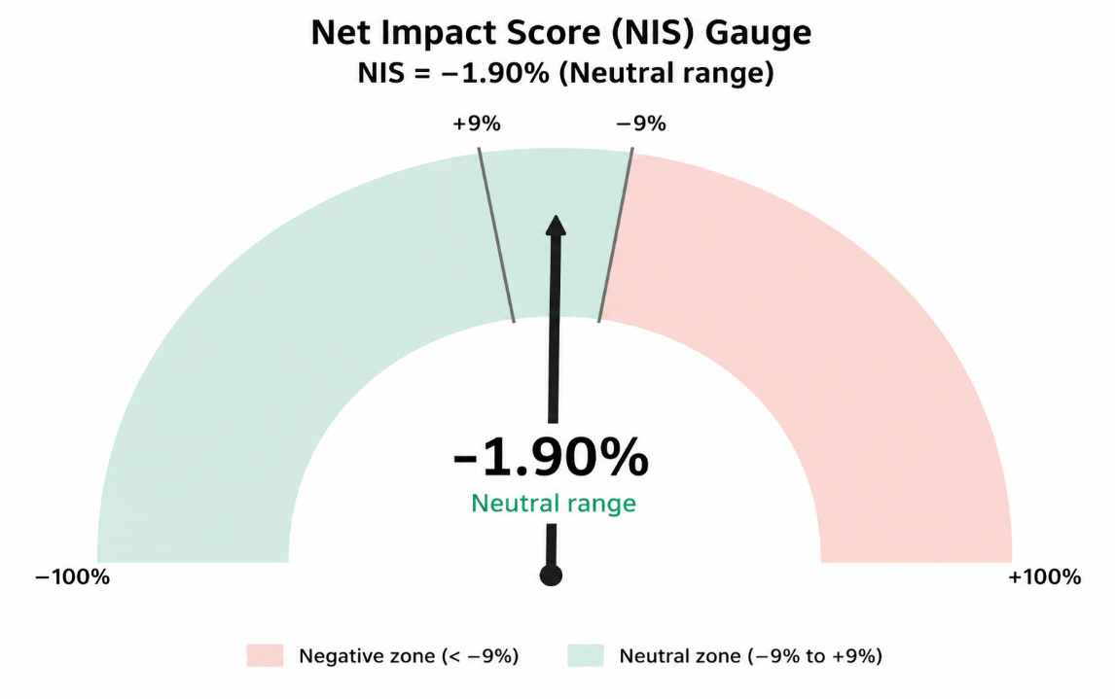

Interpretation:
The gauge shows a Net Impact Score of −1.90%, which falls within the neutral range. This means the overall impact is slightly negative but very close to balanced.

Conclusion:
Overall, the results indicate a neutral impact, suggesting that positive and negative effects are nearly equal with no strong overall influence.

3.Holistic Impact Across Key Dimensions :

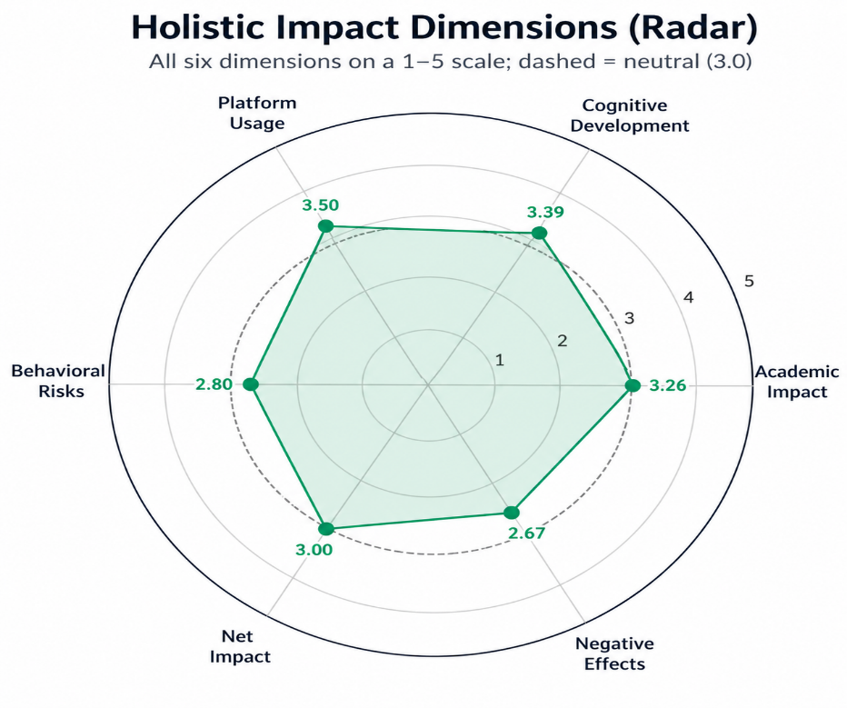
Interpretation:
The radar chart shows that most areas are close to the neutral level (3.0). Platform usage (3.50) and cognitive development (3.39) are slightly positive, while behavioral risks (2.80) and negative effects (2.67) are lower. Academic impact (3.26) is moderately positive, and overall net impact stays neutral.

Conclusion:
Overall, the findings suggest a balanced impact across different dimensions, with slight positives in usage and learning, but some concerns in behavioral and negative effects.

9. Conclusion:

This study provides a rigorous, multi-method statistical examination of AI usage and its impacts among
school students in Vadodara. The following conclusions emerge from the analysis:

• AI adoption is widespread: 87.2% of the sample (n=303/340) use AI tools, with ChatGPT
(55.8%) and Google Gemini (48.8%) dominating, primarily for academic purposes (87%).

• AI positively impacts students: The Positive Impact Score is significantly above neutral
(M=3.257, t(302)=6.484, p<0.001, d=0.373). Academic understanding, problem-solving, and
independent learning are the most strongly endorsed benefits.

• AI does not strongly harm students: The Negative Impact Score is significantly below neutral
(M=2.667, t(302)=−8.842, p<0.001, d=−0.508). Students do not strongly perceive dependency,
anxiety, or social isolation from AI use.

• Procrastination is the most endorsed concern: Q36 (M=2.878) and reduced interpersonal
conversational satisfaction (Q33, M=2.865) are closest to the neutral threshold and merit
attention.

• Platform usage is highly skewed: ChatGPT dominates significantly over all other platforms
(χ²(2)=36.32, p<0.001), reflecting clear market concentration in student AI preferences.

• Behavioral risk is context-dependent: Students who prefer talking to AI over people (H=10.59,
p=0.005) and those whose sleep is affected (H=44.84, p<0.001) show significantly higher
negative impact scores.

• Usage quantity is not a proxy for quality: Frequency and duration of AI use do not predict
positive cognitive outcomes (r=−0.037, p=0.60). Purpose and quality of engagement determine
perceived benefit.

• Net Impact is neutral-to-positive: The Net Impact Score of −1.90% falls in the neutral range, but
the asymmetry of t-test results (positives significantly above neutral, negatives significantly
below neutral) indicates a net benefit from AI us
Limitations :
• Self-report bias: All data are based on student self-report, which is susceptible to social desirability and recall biases. Objective measures of AI use (e.g., screen time data) were not available.
• Cross-sectional design: The survey captures a single point in time; causal inferences cannot be drawn from correlational data. A longitudinal design would be required to establish directionality.
• Non-random platform representation: The study was restricted to Vadodara schools, limiting generalisability to other demographic contexts (rural, national, or international populations).
• Missing data exclusion: The structural exclusion of non-users (n=37) from scale analysis, while theoretically justified, limits the ability to compare AI users to non-users on outcome measures.
• Multi-response platform variable: Q13 (platform usage) was multi-response; respondents could select multiple platforms, preventing mutually exclusive group assignment for inferential testing beyond frequency analysis.
• Construct measurement: The scales for positive and negative impact were purpose-built without prior psychometric validation in the Indian school context; future studies should conduct confirmatory factor analysis (CFA) to establish construct validity formally.
• LowR² in regression: The multiple regression model explains only 0.72% of variance in positive impact scores, suggesting important predictors (e.g., type of AI use, academic discipline, prior academic performance) were not captured in the survey

10. References:

- Abbasi, M. U. R., Zulfiqar, A., Rasool, M. S., and Quadri, S. S. A. (2024). Impact of AI on the inclusion of learners with special needs: public policy perspective in contemporary scenario, vol. 11: Arbor.

- Akgun, S., and Greenhow, C. (2022). Artificial intelligence in education: addressing ethical challenges in K-12 settings. AI Ethics 2, 431–440. Doi : 10.1007/s43681-021-00096-7

- Al-Zahrani, A. M. (2024). Unveiling the shadows: beyond the hype of AI in education. Heliyon 10:e30696. doi: 10.1016/j.heliyon.2024.e30696

- Budhwar , P., Malik, A., De Silva, M. T. T., and Thevisuthan, P. (2022). Artificial intelligence – challenges and opportunities for international HRM: a review and research agenda. Int. J. Hum. Resour. Manag. 33, 1065–1097.

- Cronbach, L. J. (1951). Coefficient alpha and the internal structure of tests. Psychometrika, 16(3), 297–334.

- Cohen, J. (1988). Statistical power analysis for the behavioural sciences (2nd ed.). Lawrence Erlbaum Associates.

- Shapiro, S. S., & Wilk, M. B. (1965). An analysis of variance test for normality (complete samples). Bio metrika , 52(3-4), 591–611.

- Kruskal, W. H., & Wallis, W. A. (1952). Use of ranks in one-criterion variance analysis. Journal of the American Statistical Association, 47(260), 583–621.

- Wilcoxon, F. (1945). Individual comparisons by ranking methods. Biometrics Bulletin, 1(6), 80–83.

- Nunnally, J. C. (1978). Psychometric theory (2nd ed.). McGraw-Hill.
- Gerlich, M. (2025). AI tools in society: Impacts on cognitive offloading and the future of critical thinking. Societies, 15(1), 6.

- Nguyen, A., et al. (2024). The impact of AI usage on university students' willingness for autonomous learning. Education and Information Technologies.

- Goh, A. Y. H., Hartanto, A., & Majeed, N. M. (2023). Generative artificial intelligence dependency: Scale development and validation. Singapore Management University; National University of Singapore.

- Pearson, K. (1900). On the criterion that a given system of deviations from the probable in the case of a correlated system of variables is such that it can be reasonably supposed to have arisen from random sampling. Philosophical Magazine, 5(50), 157–175.

Appendix A: Complete Questionnaire :

Title: Artificial Intelligence and Student Life: A Study of Its Influence on Learning, Behaviour, and Social Life

SECTION A: DEMOGRAPHIC INFORMATION :

- Name : _____________________________________________
- Age
___________
- Gender
(A) Male (B) Female (C) Prefer not to say
- Academic level
8th 9th 10th 11th 12th
- School Details (Name, Type, Medium )
School Name: _____________________________________________________
Type: Govt / Govt Granted / Private (CBSE/Other)
Medium: English / Gujarati / other_______
- Living situation
(A) Hostal (B) With relative (C) With family
- Do you use AI?
Yes / No

SECTION B: AI USAGE & PLATFORMS :

8. Are you aware that AI can be used beyond academics (emotional support, well-being)?
(A) Yes (B) Somewhat (C) No

9. How often do you use AI tools for your daily life or studies?

(A) Regularly (B) Occasionally (C) No

10. For how long have you been using AI tools?

(A) <3 months (B) 3–6 months (C) 6–12 months (D) >1 year

11. How frequently do you use AI tools ?

(A) Multiple times/day (B) Daily (C) Weekly (D) Monthly

12. Average daily AI usage time

(A) <30 min (B) 30–60 min (C) 1–2 hrs (D) >2 hrs

13. Which AI platforms or tools do you use most often?

(A) ChatGPT (B) Google Gemini (C) Copilot (D) Character.AI ( E ) Mental health apps
(F) NotebookLM (G) Social media AI (F) Other____________________

14. Primary purpose of AI use

(A) Academic (B) Emotional support (C) Stress relief
(D) Social/companionship ( E ) Productivity (F ) Other_________________

SECTION C: POSITIVE IMPACTS OF AI (Q15–Q26):

(Scale: 1 = Strongly Disagree to 5 = Strongly Agree)
Q# | Statement | 1 | 2 | 3 | 4 | 5
Q15 | AI helps reduce my stress | ○ | ○ | ○ | ○ | ○
Q16 | AI improves my emotional well-being | ○ | ○ | ○ | ○ | ○
Q17 | AI provides comfort when I feel low | ○ | ○ | ○ | ○ | ○
Q18 | AI improves my academic understanding | ○ | ○ | ○ | ○ | ○
Q19 | AI enhances my productivity | ○ | ○ | ○ | ○ | ○
Q20 | AI improves my problem-solving skills | ○ | ○ | ○ | ○ | ○
Q21 | AI supports independent learning | ○ | ○ | ○ | ○ | ○
Q22 | AI increases my confidence in studies | ○ | ○ | ○ | ○ | ○
Q23 | AI helps me manage time better | ○ | ○ | ○ | ○ | ○
Q24 | AI supports work–life balance | ○ | ○ | ○ | ○ | ○
Q25 | AI encourages self-reflection | ○ | ○ | ○ | ○ | ○
Q26 | Overall, AI positively supports my well-being | ○ | ○ | ○ | ○ | ○

SECTION D: NEGATIVE IMPACTS OF AI (Q27–Q38) :

(Scale: 1 = Strongly Disagree to 5 = Strongly Agree)

Q# | Statement | 1 | 2 | 3 | 4 | 5
Q27 | I feel emotionally dependent on AI | ○ | ○ | ○ | ○ | ○
Q28 | I prefer AI over people for emotional support | ○ | ○ | ○ | ○ | ○
Q29 | I feel anxious when I can't access AI | ○ | ○ | ○ | ○ | ○
Q30 | AI reduces my face-to-face interactions | ○ | ○ | ○ | ○ | ○
Q31 | AI use has increased my loneliness | ○ | ○ | ○ | ○ | ○
Q32 | AI increases my anxiety at times | ○ | ○ | ○ | ○ | ○
Q33 | AI makes human conversations less satisfying | ○ | ○ | ○ | ○ | ○
Q34 | I rely on AI validation more than human feedback | ○ | ○ | ○ | ○ | ○
Q35 | I feel unable to study effectively without AI support | ○ | ○ | ○ | ○ | ○
Q36 | AI contributes to procrastination | ○ | ○ | ○ | ○ | ○
Q37 | AI makes me less physically active | ○ | ○ | ○ | ○ | ○
Q38 | I feel less motivated to brainstorm without AI | ○ | ○ | ○ | ○ | ○

SECTION E: BEHAVIOURAL & SOCIAL PATTERNS (Q39–Q46):

39. Have you experienced any changes in your mental well-being before or after using AI
tools?

Yes, before / yes, after / yes, both / No

40. How often do you use AI for emotional support?

Daily / weekly / monthly / rarely / never

41. Do you feel more comfortable talking to AI than talking to people?

Yes / sometimes / No

42. Has AI use affected your sleep quality?

Improved / No change / Declined

43. Have you avoided social plans to use AI?

Yes / occasionally / No

44. Compared to before AI use, your social life is

Better / same / worse

45. Has AI use affected your communication skills with peers?

Improved / No change / Declined

46. Has AI influenced your confidence in making decisions without human input?

More confident / no change / Less confident

47. Write ONE good & bad habit you learned after using AI.

(Example:
Good: better time management, calm thinking, improved learning
Bad: Distraction, Isolation, Dependency)

